**Exercise 1: Control Structures**

**Scenario 1:** The bank wants to apply a discount to loan interest rates for customers above 60 years old.

* + **Question:** Write a PL/SQL block that loops through all customers, checks their age, and if they are above 60, apply a 1% discount to their current loan interest rates.

**Queries:**

INSERT INTO Customers (CustomerID, Name, DOB, Balance, LastModified) VALUES (101, 'Ravi Kumar', TO_DATE('1950-08-20', 'YYYY-MM-DD'), 5000, SYSDATE);

INSERT INTO Customers (CustomerID, Name, DOB, Balance, LastModified) VALUES (102, 'Meena Iyer', TO_DATE('1958-03-10', 'YYYY-MM-DD'), 3000, SYSDATE);

INSERT INTO Customers (CustomerID, Name, DOB, Balance, LastModified) VALUES (103, 'Arjun Rao', TO_DATE('1988-09-25', 'YYYY-MM-DD'), 4000, SYSDATE);

INSERT INTO Loans (LoanID, CustomerID, LoanAmount, InterestRate, StartDate, EndDate) VALUES (201, 101, 20000, 8.5, SYSDATE, ADD_MONTHS(SYSDATE, 60));

INSERT INTO Loans (LoanID, CustomerID, LoanAmount, InterestRate, StartDate, EndDate) VALUES (202, 102, 15000, 7.0, SYSDATE, ADD_MONTHS(SYSDATE, 48));

INSERT INTO Loans (LoanID, CustomerID, LoanAmount, InterestRate, StartDate, EndDate) VALUES (203, 103, 10000, 9.0, SYSDATE, ADD_MONTHS(SYSDATE, 36));

COMMIT;

**PL/SQL:**

BEGIN

FOR rec IN (

SELECT c.CustomerID, c.Name

FROM Customers c

JOIN Loans l ON c.CustomerID = l.CustomerID

WHERE TRUNC(MONTHS_BETWEEN(SYSDATE, c.DOB) / 12) > 60

) LOOP

UPDATE Loans

SET InterestRate = InterestRate - 1

WHERE CustomerID = rec.CustomerID;

IF SQL%ROWCOUNT > 0 THEN

DBMS_OUTPUT.PUT_LINE('Updated: ' || rec.CustomerID || ' - ' || rec.Name);

END IF;

END LOOP;

COMMIT;

END;

/

**Output:**

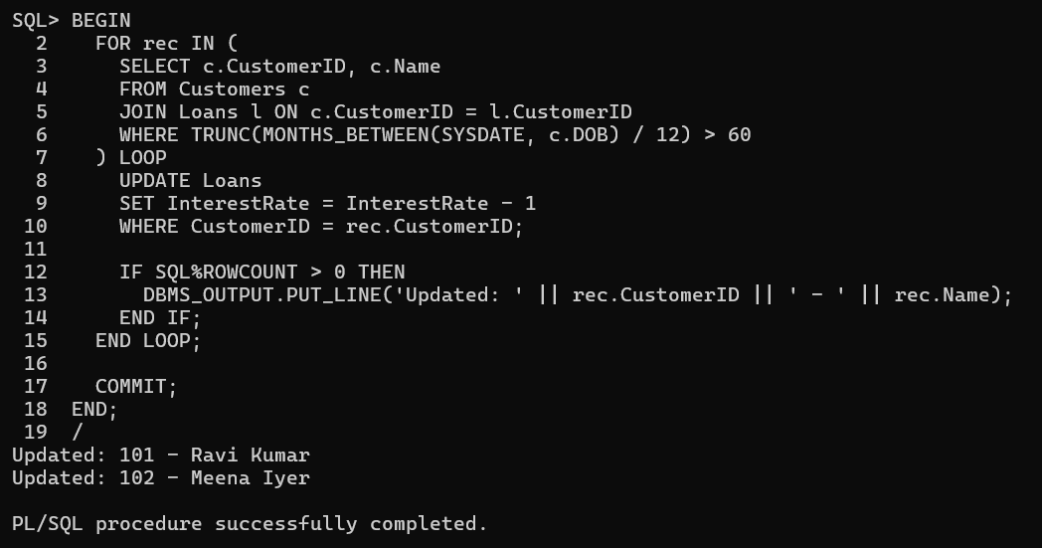

**Scenario 2:**

A customer can be promoted to VIP status based on their balance.

* + **Question:** Write a PL/SQL block that iterates through all customers and sets a flag IsVIP to TRUE for those with a balance over $10,000.

**Queries:**

ALTER TABLE Customers ADD IsVip CHAR(5) DEFAULT ‘FALSE’; -- Stores 'TRUE' or 'FALSE';

**PL/SQL :**

BEGIN

FOR rec IN (

SELECT CustomerID, Name, Balance FROM Customers

WHERE Balance > 10000

) LOOP

UPDATE Customers

SET IsVIP = 'TRUE'

WHERE CustomerID = rec.CustomerID;

IF SQL%ROWCOUNT > 0 THEN

DBMS_OUTPUT.PUT_LINE('Promoted to VIP: ' || rec.CustomerID || ' - ' || rec.Name);

END IF;

END LOOP;

COMMIT;

END;

/

**OutPut:**

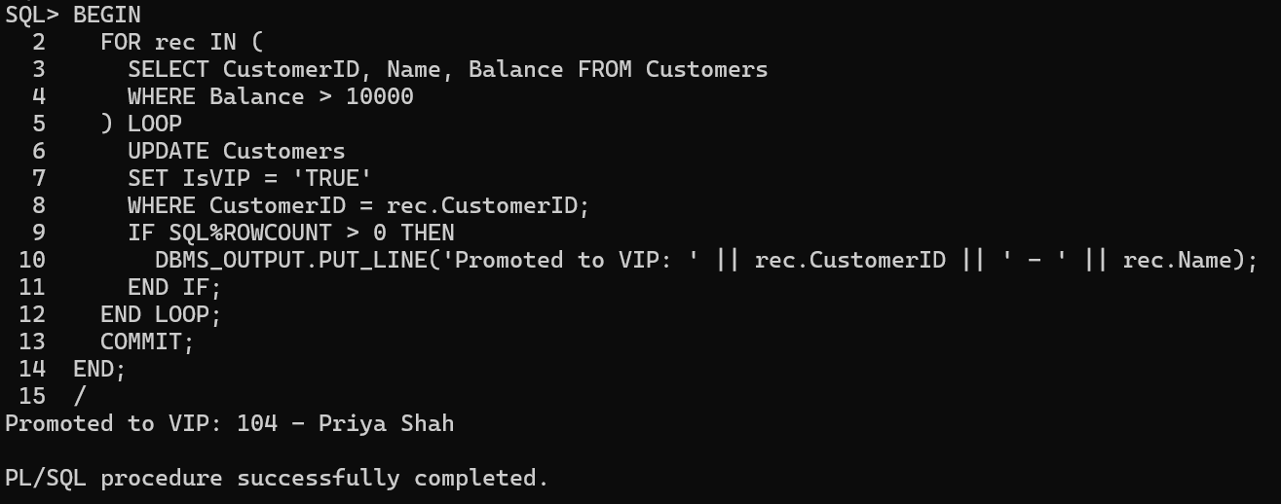

**Scenario 3:**

The bank wants to send reminders to customers whose loans are due within the next 30 days.

* + **Question:** Write a PL/SQL block that fetches all loans due in the next 30 days and prints a reminder message for each customer.

**Queries:**

INSERT INTO Loans (LoanID, CustomerID, LoanAmount, InterestRate, StartDate, EndDate) VALUES (301, 101, 10000, 7.5, SYSDATE - 300, SYSDATE + 10);

INSERT INTO Loans (LoanID, CustomerID, LoanAmount, InterestRate, StartDate, EndDate) VALUES (302, 102, 15000, 8.0, SYSDATE - 100, SYSDATE + 40);

**PL/SQL:**

BEGIN

FOR rec IN (

SELECT c.CustomerID, c.Name, l.LoanID, l.EndDate

FROM Customers c

JOIN Loans l ON c.CustomerID = l.CustomerID

WHERE l.EndDate BETWEEN SYSDATE AND SYSDATE + 30

) LOOP

DBMS_OUTPUT.PUT_LINE(

'Reminder: Loan ID ' || rec.LoanID || ' for Customer ' || rec.Name ||

' (ID: ' || rec.CustomerID || ') is due on ' || TO_CHAR(rec.EndDate, 'DD-Mon-YYYY')

);

END LOOP;

END;

/

**OutPut:**

